**Bug Report – TutorialsNinja**

|  |  |  |
| --- | --- | --- |
| **Bug#** | **Description** | **Severity** |
| TW1-I1 | 'Thank you for registering' email is not received to the registered email address after registering an account | Minor |
| TW1-I2 | User is able to register an account by providing an invalid phone number | Major |
| TW1-I3 | Telephone, Password and Password Confirm fields are Accepting spaces. | Major |
| TW1-I4 | Account got created for without following any Password Complexity Standards. | Major |
| TW1-I5 | Verify Logging out from the Application and browsing back using Browser back button | Major |
| TW1-I6 | Verify logging out and browsing back | Major |
| TW1-I7 | Verify logout from an Account from a single place after logging into it from different places | Minor |
| TW1-I8 | Verify functionlity for by providing Valid data and check that Email Forgot password link is sent or not | Major |
| TW1-I9 | Verify the functionality after click on the forgot password and then click on browser back button | Minor |
| TW1-I10 | Verify that confirmation message showing or not when user delete the item into the Add to Cart | Minor |
| TW1-I11 | Verify that a message showing or not when user click on header of the Account page options | Minor |
|  |  |  |
|  |  |  |
|  |  |  |
|  |  |  |
|  |  |  |
|  |  |  |
|  |  |  |
|  |  |  |
|  |  |  |
|  |  |  |
|  |  |  |
|  |  |  |

|  |  |
| --- | --- |
| Bug Id | TW1-I1 |

|  |  |
| --- | --- |
| Brief Summary | 'Thank you for registering' email is not received to the registered email address after registering an account |

|  |  |
| --- | --- |
| Severity | Minor |

|  |
| --- |
| Steps to Reproduce |

1. Open the Application URL

2. Click on 'My Account' dropmenu

3. Select 'Register' option

4. Enter the new User valid details into the 'Register Account' page

5. Select the 'Privacy Policy' checkbox option

6. Click on 'Continue' button

**Expected Result:**

User Account should be created and an email with the subject 'Thank you for registering' should be received by the registered email address.

**Actual Result:**

User Account is getting created, but the email with subject 'Thank you for registering' is not received to the registered email address.

|  |
| --- |
| Screenshot |

Not Applicable

|  |  |
| --- | --- |
| Bug Id | TW1-I2 |

|  |  |
| --- | --- |
| Brief Summary | User is able to register an account by providing an invalid phone number |

|  |  |
| --- | --- |
| Severity | Major |

|  |
| --- |
| Steps to Reproduce |

1. Open the Application URL

2. Click on 'My Account' dropmenu

3. Select 'Register' option

4. Enter valid details into the fields displayed on the 'Register Account' page

5. Enter invalid phone number say **abcde**into the 'Telephone' field

6. Select 'Privacy Policy' checkbox field

7. Click on 'Continue' button

**Expected Result:**

Warning message should be displayed informing the Users about the invalid phone number

**Actual Result:**

Warning message is not getting displayed, instead User account is getting created with invalid phone number

|  |
| --- |
| Screenshot |

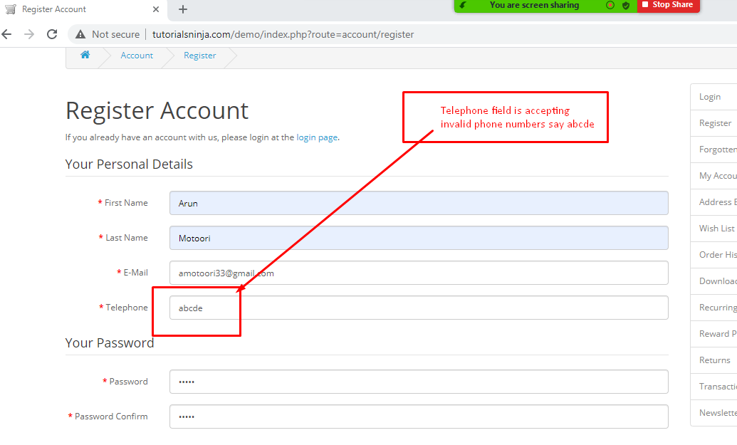

|  |  |
| --- | --- |
| Bug Id | TW1-I3 |

|  |  |
| --- | --- |
| Brief Summary | Verify whether the Mandatory fields in the Register Account page are accepting only spaces. |

|  |  |
| --- | --- |
| Severity | Major |

|  |
| --- |
| Steps to Reproduce |

1. Click on 'My Account' Drop menu

2. Click on 'Register' option

3. Enter spaces into the Mandatory Fields (First Name, Last Name, E-Mail,Telephone, Password and Password Confirm)

4. Click on 'Continue' button (ER-1)

**Expected Result (ER):**

1. Warning message should be displayed for these Mandatory fields

**Actual Result:**

1.User got the Warning message in Fname ,Lname ,and E-mail fields only.

2.But in Telephone, Password and Password Confirm fields are Accepting spaces.

|  |
| --- |
| Screenshot |

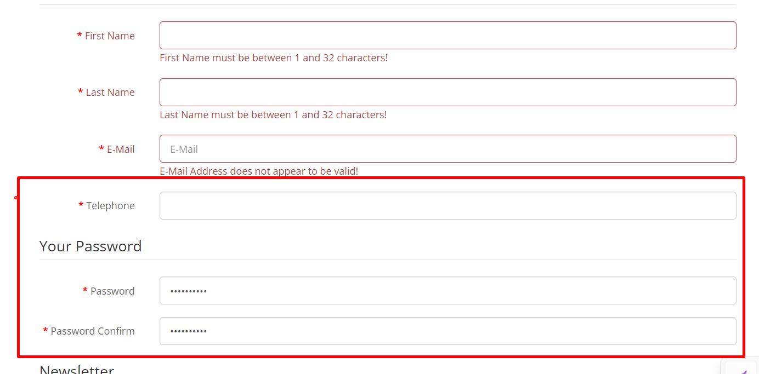

|  |  |
| --- | --- |
| Bug Id | TW1-I4 |

|  |  |
| --- | --- |
| Brief Summary | Account got created for without following any Password Complexity Standards. |

|  |  |
| --- | --- |
| Severity | Major |

|  |
| --- |
| Steps to Reproduce |

1. Click on 'My Account' Drop menu

2. Click on 'Register' option

3. Enter new Account Details into all the Fields (First Name, Last Name, E-Mail,Telephone, Newsletter and  Privacy Policy Fields)

4. Check entering simple passwords (Not following Password Complexity Standars' i.e. Size of password as 8, password should contain atleat one number, symbol, lower case letter and upper case letters) - <Refer Test Data>

5. Click on 'Continue' button (ER-1)

**Expected Result (ER):**

1. Warning message should be displayed for following Password Complexity Standards

**Actual Result:**

1.Account got created for without following any Password Complexity Standards

|  |
| --- |
| Screenshot |

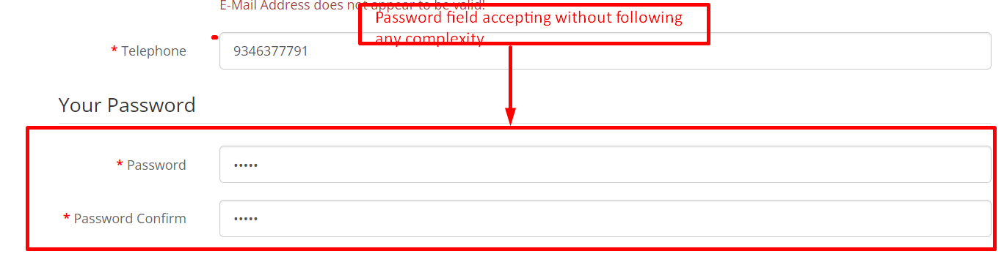

|  |  |
| --- | --- |
| Bug Id | TW1-I5 |

|  |  |
| --- | --- |
| Brief Summary | Verify Logging out from the Application and browsing back using Browser back button |

|  |  |
| --- | --- |
| Severity | Major |

|  |
| --- |
| Steps to Reproduce |

1. Click on 'My Account' Drop menu

2. Click on 'Login' option

3. Enter valid email address into the 'E-Mail Address' field - <Refer Test Data>

4. Enter valid password into the 'Password' field - <Refer Test Data>

5. Click on 'Login' button

6. Click on 'My Account' Drop menu and select 'Logout' option

7. Click on Browser back button (ER-1)

**Expected Result (ER):**

1. User should not get logged in again

**Actual Result:**

User  getting login after logout and again clicking browser back button

|  |  |
| --- | --- |
| Bug Id | TW1-I6 |

|  |  |
| --- | --- |
| Brief Summary | Verify logging out and browsing back |

|  |  |
| --- | --- |
| Severity | Major |

|  |
| --- |
| Steps to Reproduce |

1. Click on 'My Account' Dropmenu

2. Select 'Logout' option

3. Click on Browser back button (Verify ER-1)

**Expected Result (ER):**

1. User should not get logged in

**Actual Result:**

User getting login by clicking browser back button.

|  |
| --- |
| Screenshot |

Not Applicable

|  |  |
| --- | --- |
| Bug Id | TW1-I7 |

|  |  |
| --- | --- |
| Brief Summary | Verify logging out and browsing back |

|  |  |
| --- | --- |
| Severity | Minor |

|  |
| --- |
| Steps to Reproduce |

1. Click on 'My Account' Dropmenu in Firefox Browser

2. Select 'Logout' option

3. Perform any operation which requires the user to log, say navigating to Address Book page in the Chrome Browser of Mobile device (Verify ER-1)

**Expected Result (ER):**

1. User be logged out in Mobile device too, instead of getting navigated to the Address book page

**Actual Result:**

User still in login page after logged out in the other browser.

|  |
| --- |
| Screenshot |

Not Applicable

|  |  |
| --- | --- |
| Bug Id | TW1-I8 |

|  |  |
| --- | --- |
| Brief Summary | Verify functionality for by providing Valid data and check that Email Forgot password link is sent or not |

|  |  |
| --- | --- |
| Severity | Major |

|  |
| --- |
| Steps to Reproduce |

1.click on MyAccount Drop down

2.Click on Login Option(ER-1)

3.Click on Forgot Password (ER-2)

4.Give the data in the Email field<Refer Test Data>

5.Click on continue button(ER-3)

6.Check the link is provide or not(ER-4)

**Expected Result (ER):**

1.User should navigated to login page

2.User should navigated to Forgot Password page

3.An email with a confirmation link has been sent your email address

4.User should get the email by provide

change the Password link

**Actual Result:**

1.User got navigate to login page

2.User got Forgot password page

3.User got confirmation message as per the exceptions

4.User not got that email.

|  |
| --- |
| Screenshot |

Not Applicable

|  |  |
| --- | --- |
| Bug Id | TW1-I9 |

|  |  |
| --- | --- |
| Brief Summary | Verify the functionality after click on the forgot password and then click on browser back button |

|  |  |
| --- | --- |
| Severity | Minor |

|  |
| --- |
| Steps to Reproduce |

1. Click on 'My Account' Dropmenu

2. Click on 'Login' option (ER-1)

3. Click on 'Forgot Password' button(ER-2)

4.After click on browser back button

5.open the URL link in any browser(ER_3)

**Expected Result (ER):**

1.User should navigated to login page

2.User should navigated to Forgot Password page

3.User should not go back the Home Page

**Actual Result:**

1.User got navigated to login page

2.User got navigated to Forgot Password page

3.User will go back the Home Page

|  |
| --- |
| Screenshot |

Not Applicable

|  |  |
| --- | --- |
| Bug Id | TW1-I10 |

|  |  |
| --- | --- |
| Brief Summary | Verify that confirmation message showing or not when user delete the item into the Add to Cart |

|  |  |
| --- | --- |
| Severity | Minor |

|  |
| --- |
| Steps to Reproduce |

1.Click on Shopping  Cart button

2.Deelet the item from the shopping cart (ER-1)

**Expected Result (ER):**

User should get one confirmation message like

(Success: You have added HTC Touch HD to your shopping cart!)

**Actual Result:**

User should not got confirmation message

|  |
| --- |
| Screenshot |

Not Applicable

|  |  |
| --- | --- |
| Bug Id | TW1-I11 |

|  |  |
| --- | --- |
| Brief Summary | Verify that a message showing or not when user click on header of the Account page options |

|  |  |
| --- | --- |
| Severity | Minor |

|  |
| --- |
| Steps to Reproduce |

1.Click on Any item on the header of the Account page

2.User should be  displayed one message when the user click on header of the Account page options if item is available or not

**Expected Result (ER):**

User should get one message like

(There are no products to list in this category.)

**Actual Result:**

User should got one message

|  |
| --- |
| Screenshot |

Not Applicable